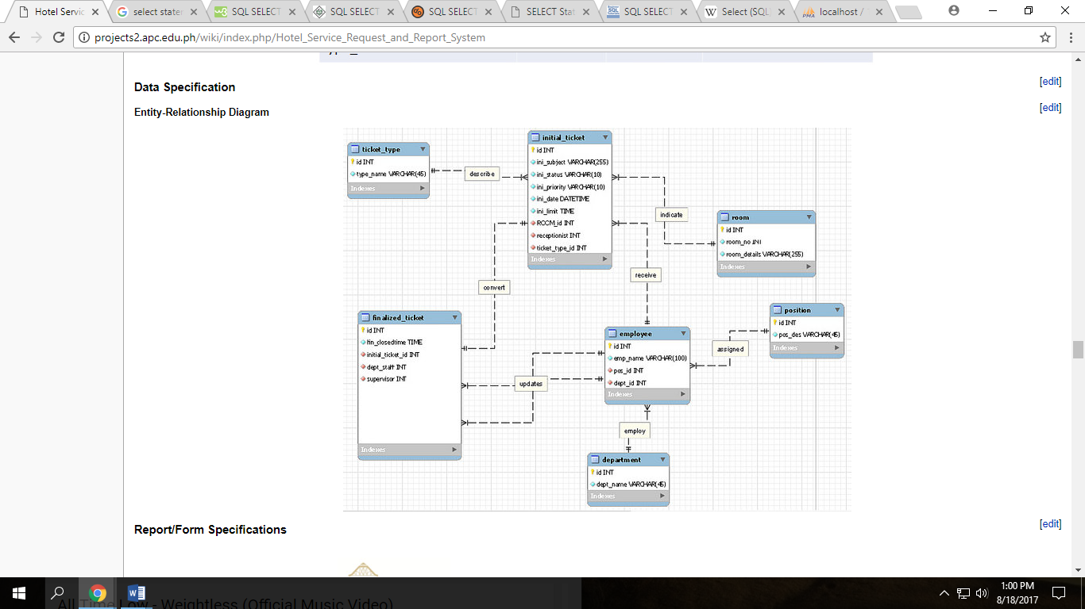

|  |  |
| --- | --- |
| **Requests received** | **Request** |
| **Guest Aircon Assistance** | **21** |
| **Busted Bulb** | **15** |
| **Guest Assistance - Others** | **11** |
| **Guest TV Assistance** | **11** |
| Guest Door Lock Assistance | 7 |
| Carpentry Works | 3 |
| Guest Toilet Assistance | 3 |
| Plumbing Works | 2 |
| Clogged Toilet | 1 |
| Electrical Works | 1 |
| Guest Electrical Assistance | 1 |
| Guest Telephone Assistance | 1 |
| Leak Fixing | 1 |

*the goal is to Select ticket type id from the initial ticket table for it is the FK but you must show the ticket type name instead of the id

*then after showing the type name it should show the count() where it will display how many times it has been requested

*Sort by count from highest to lowest

Select ticket_type_id From initial_ticket

* Ticket type

|  |  |
| --- | --- |
| **Rooms with more than one issue reported** | |
| **467** | **4** |
| **201** | **3** |
| 117 | 2 |
| 204 | 2 |
| 210 | 2 |
| 247 | 2 |
| 267 | 2 |
| 322 | 2 |
| 361 | 2 |
| 378 | 2 |
| 384 | 2 |

* if room number appear in the ticket more than 1 times

|  |  |
| --- | --- |
| **Common Item Requests** | |
| **towel** | **95** |
| **Bottled water** | **62** |
| **Pillows** | **61** |
| Blanket | 29 |
| dipper | 28 |
| set of toiletries | 22 |
| RAB | 18 |
| Laundry bag | 18 |
| bedsheet | 12 |
| dental kit | 10 |
| Pail | 9 |
| shaving kit | 8 |
| Coffee set | 6 |
| shampoo | 6 |
| slippers | 6 |
| bath robe | 5 |
| Takeout trash | 4 |
| conditioner | 3 |
| soap | 3 |

*